84.07.14a
From Joseph Maiden
MRS 7/1 minor correspondence - outwards 1883-9, pp. 321-3, Powerhouse Museum, Sydney.

14th July [188]4
Sir,
I beg to acknowledge the receipt of your letter of the 7th Inst: and to state that at the next meeting of the Committee of Management I shall have the pleasure of communicating your valuable donation of 42 samples of Australian timbers to this Museum, & at that meeting Mr Walter's account will be settled.
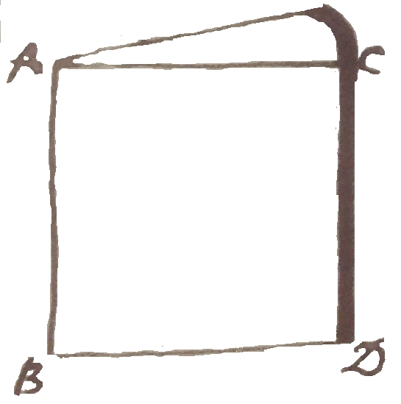
Want of space for the workmen has been the great drawback in getting wood-samples worked up in this Museum, but the Committee is fully alive to the importance of disseminating reliable information in regard to the timber resources of this Colony, and, as opportunities present themselves I am endeavouring to get together a really good collection of woods. The idea of wood-books for reference is excellent, & will be availed of here especially on account of economy of space, but the wood-collections which will be most used by the general public are of this shape: — in which AB shows the heart-wood & CD the bark. The length AB or CD is generally about 10 inches. The thickness of the wedge depends on the size of the tree from which it is taken, & is usually of such a thickness that it can comfortably stand on end.
As soon as the samples of timber (42) referred to in your letter, arrive, I will acknowledge the receipt of them.
I have the honour to be,
Sir,
Your obedient Servant,
J. H. Maiden.

The Baron Ferd. von Mueller K.C.M.G., F.R.S.
&c &c &c
Melbourne

editorial addition. The text is from a letter copy book.
See M to J. Maiden, 7 July 1884 (in this edition as 84-07-07a).
A sketch is inserted here: 84-07-14a_image01.jpg.
Letter not found; but see J. Maiden to M, 31 July 1884 (in this edition as 84-07-31b).

